**Camera Zoom**

Studata > GDT 225 > Course Data > Drag tunnel.ai to your desktop

Import tunnel.ai into AE as composition retain layer sizes

Layer the layers as shown;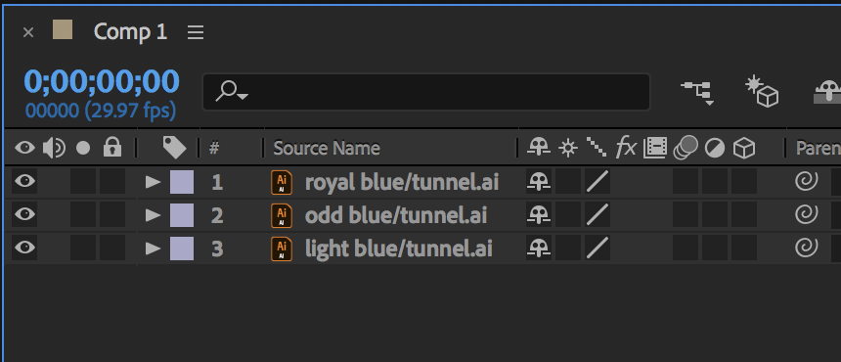

Layer > New > Camera > 50 mm > ok

Click on the 3D box on each of the layers

Select the three blue layers and parent to the Camera layer using the Pick Whip tool

**Camera**

* Open the transform properties and the Camera Options part
* Press Home
* Click on the stopwatch for Zoom
* Press End
* Scrub the zoom value until you have the desired effect